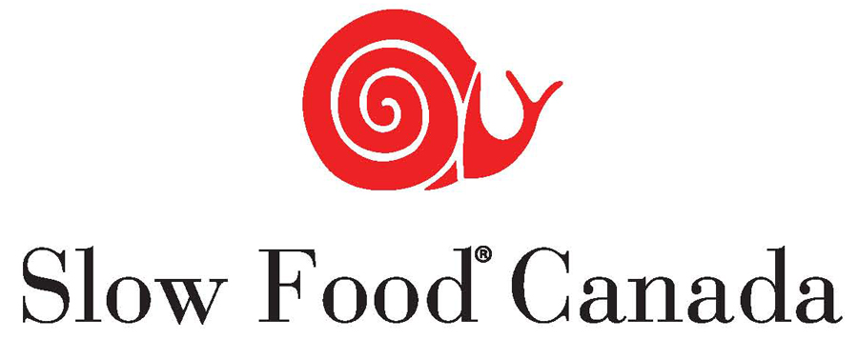

Slow Food Canada Launches the Slow Fish Canada Campaign

Canada – Slow Food Canada is excited to announce the creation of the Slow Fish Canada campaign, a national group that will focus efforts on issues related to fisheries. During the 2013 Annual General Meeting, held last April in Osoyoos, BC, the membership voted unanimously for the creation of the national campaign.

Fishing is a particularly critical issue, given the dwindling state of global fish stocks, pollution of the oceans and its impact on the livelihood of small-scale fishing communities. By engaging the entire Canadian Slow Food network, the Slow Fish Canada campaign will invite people to find local solutions that support a better management of our freshwater and marine resources.

“The Slow Food approach is based on three tenets: food that is good, clean & fair,” says Dave Adler of Nova Scotia’s Ecology Action Centre, “The same is true of Slow Fish. We hope to support, discover, and celebrate Canada’s small scale, sustainable fisheries by connecting people who eat seafood to the people who catch it, harvest it, and grow it.”

Building on Slow Fish International the Slow Fish Canada campaign will focus primarily on promoting artisanal fishing and neglected fish species. The campaign will also address issues such as access to good, clean and fair fish for consumers; fair remuneration and access to regional markets for small-scale producers; social finance and succession planning for fisheries; fair access to quotas by independent owner-operator fishing enterprises; and support of new and developing fisheries. Slow Fish Canada also plans to develop awareness campaigns around important issues such as aquaculture and eco-certification of seafood. Slow Fish Canada will raise awareness around salmon conservation by building on the Wild Salmon Manifesto, which was adopted by Slow Food Canada in 2006.

Slow Food Canada has been active in different regions of the country for more than 10 years, with a particularly strong presence in the Maritimes, Montreal, Ontario and British Columbia. Today, more than thirteen hundred members belong to thirty convivia that span the country from Newfoundland and Cape Breton Island to Vancouver Island and Whitehorse in the Yukon.

Slow Fish Canada Campaign  David Adler  dadler@ecologyaction.ca  (902) 442-0999 | Slow Food Canada – General Inquiries  Valerie Lugonja  valerie@acanadianfoodie.com  (780) 709-7902

Slow Fish is an international campaign launched by Slow Food International to promote good, clean and fair fish by informing consumers and encouraging interaction between those involved in the world of sustainable fisheries. For more information, please visit: www.slowfood.it/slowfish/welcome_en.lasso.

